"Note: It's okay if you don't know about some topics. Just search and try to give your best answer."

For statistics questions this may help : link, link

Main Questions :

Q1) What is the difference between mean, median and mode?
Mean : the average of the dataset
Median : the middle value of the ordered dataset
Mode : the number that occurs most often in dataset

Q2) What is the difference between left and right skewness of the data?
the right-skewed distribution is longer on the right side of its peak than on its left
the left-skewed distribution is longer on the left side of its peak than on its right

Q3) What is the difference between list and tuples in Python?
List is mutable and tuple is unmutable

Q4) How can you generate random numbers in Python?
From random module ,using random() function

Q5) What is break, continue and pass in Python?
Break : exit the loop
Continue : make the loop continue or excute the next iteration

Figure 1 :
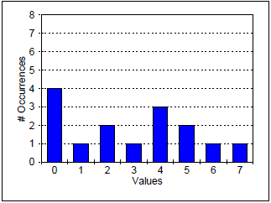

Q6) Find the median of the data in Figure 1.
3.5

Q7) Find the standard deviation of the data in Figure 1.
Mean = 28/8 = 3.5
Sum (Xi – X')^2 = 42
Standard deviation = $$\sqrt{\frac{42}{6}}$$ = $$\sqrt{6}$$ = 2.45

Figure 2 :
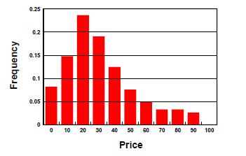

Q8) Which of the following best describes the data in Figure 2? (Base your answer on the appearance of the histogram.)
You do not need to do any calculations. Select just one statement below and complete the one you select.

a) The mean is greater than the median because

b) The median is greater than the mean because

c) The mean and median are roughly equal because
The mean = 450 / 10 = 45
The median = (40 + 50) / 2 = 45

Q9) Given a list of integers numbers = [3, 7, 2, 8, 1], write a Python code snippet to find and print the maximum value in the list.

Li = [3,7,2,8,1]

Max = Li[0]

for i in range(len(Li)):
if Li[i] > Max:
Max = Li[i]

print(Max)

Q10) What is an outlier in a dataset, and how would you explain it to someone who is new to statistics?

data points that are far from other data points
For example if we have a dataset [1,2,6,9,10,1000]
It seems that the 1000 is the outlier value

PS Problems :

https://codeforces.com/problemset/problem/791/A
Answer link :
https://codeforces.com/problemset/submission/791/236498559

https://codeforces.com/problemset/problem/58/A
Answer link :
https://codeforces.com/problemset/submission/58/236501682

Bonus :

https://codeforces.com/problemset/problem/1624/A

Q1) What is the difference between machine learning and traditional programming?
In Traditional programming, the programmer write the exact steps required to solve the problem. While Machine Learning is motivated by human learning behavior the programmer just shows examples and let the machine figure out how to solve the problem by itself

Q2) State some examples of machine learning models ?
Classification models:
- k-nearest neighbor
- Decition trees
Regression models:
- Linear regression
- Ridge regression

